The Divorce Grieving Cycle
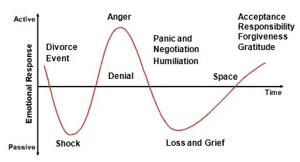
When you are going through a divorce, the roller-coaster ride can ‘feel’ very extreme. It alternates between activity and passivity in the very human and desperate efforts to avoid the change triggered by the divorce. The initial state before the cycle begins is often quite stable, at least in terms of the subsequent reaction on hearing the bad news. Compared with the ups and downs to come, even if there is some variation, this is indeed a stable state. And then, into the calm of this relative paradise, a bombshell bursts. The cycle runs as follows:
There is the initial ‘Shock’ stage which is an initial paralysis at hearing the bad news of the break up, this is followed by…
- Denial stage: Trying to avoid the inevitable
- Anger and Betrayal stage: Frustrated outpouring of bottled-up emotion
- Panic and Negotiation stage: Seeking in vain for a way out. Making deals with ex
- Humiliation, Fear of Failure or Looking Bad stage: gradually sinking into a spiral, feeling embarrassed and avoiding seeing people
- Despair stage: Realization that something horrible is coming and you are strapped into the rollercoaster with nothing you can do
- Loss, Grief and Depression stage: Final realization of the inevitable, surrendering to the grief
- Space & Nothingness stage: Once you have grieved and grieved, experiencing loss and pain. There is a feeling of ‘nothingness’ – where you cannot cry anymore
- Acceptance stage: Seeking realistic solutions and finally finding the way forward
- Responsibility and Forgiveness stage: Taking responsibility for where you may have been responsible for the relationship not working out. Forgiving your ex and yourself for any failings you feel happened during the relationship
- Gratitude stage: Transformational experience – learning from your divorce and seeing positives and negatives from the whole experience
